Two types of JavaScript
Internal & External
Example for Internal Script
<html>
<head>
<script type="text/javascript" >
function msg()
{
var thinkingOf, guess;
thinkingOf=Math.ceil(Math.random()*10);
window.alert("number"+thinkingOf);
guess=window.prompt("Enter the number","");
while(guess!=thinkingOf)
{
if(guess<thinkingOf)
guess=window.prompt("Low","");
else
guess=window.prompt("High","");
}
window.alert("Guessed Number is"+guess);
}
</script>
</head>
<body>
<p>Welcome to JavaScript</p>
<form>
<input type="button" value="click" onclick="msg()"/>
</form>
</body>
</html>

Example for External Script
First.html
<html>
<head>
<script type="text/javascript" src="message.js">
</script>
</head>
<body>
<p>Welcome to JavaScript</p>
<form>
<input type="button" value="click" onclick="msg()"/>
</form>
</body>
</html>
message.js
function msg()
{
var thinkingOf, guess;
thinkingOf=Math.ceil(Math.random()*10);
window.alert("number"+thinkingOf);
guess=window.prompt("Enter the number","");
while(guess!=thinkingOf)
{
if(guess<thinkingOf)
guess=window.prompt("Low","");
else
guess=window.prompt("High","");
}
window.alert("Guessed Number is"+guess);
}

Where can we keep script?
It can be kept both in head and in body
<html>
<head>
<script type="text/javascript" >
document.write("Hi");
</script>
</head>
<body>
<p>Welcome to JavaScript</p>
<script type="text/javascript" >
document.write("Hi");
</script>
</body>
</html>

Change the innerHTML of paragraph element
<head>
<title>
First JS Example
</title>
<script>
function changePara()
{
document.getElementById('p1').innerHTML="Praba";
}

</script>
</head>
<body>
<p id="p1" ></p>
<form>
<input type="button" value="click" onclick="changePara()"/>
</form>

</body>

Example for Mouseover and Mouseout events
<head>
<title>
First JS Example
</title>
<script>
function On()
{
document.getElementById('i1').src="bulbon.jpg";
}
function Off()
{
document.getElementById('i1').src="bulboff.jpg";
}
</script>
</head>
<body>
<img src="bulboff.jpg" id="i1" onmouseover="On()" onmouseout="Off()">
</body>
</html>

Check validity of Age
<html>
<head>
<script>
function fun()
{
var i=parseInt(document.getElementById("i1").value);
if(isNaN(i)){
document.write("Invalid age (not a number)")
}
else{
if(i<=0 || i>=110)
document.write("Invalid age");
else
document.write("Valid age");
}
}
</script>
</head>
<body>
<form>
<label>Age: <input type="text" id="i1" onchange="fun()"></label>
</form>
</body>
</html>

Example - To retrieve the values of checkboxes
<html>
<head>

<script>
function fun()
{
var markedCheckbox = document.getElementsByName("Qual");
for (var checkbox of markedCheckbox)
if (checkbox.checked)
window.alert(checkbox.value);
}
</script>
</head>
<body>
B.E. <input type="checkbox" value="BE" name="Qual">
M.E. <input type="checkbox" value="ME" name="Qual">
Ph.D <input type="checkbox" value="Ph.D" name="Qual">
<button id="btn" onclick="fun()">Click Me</button>

</body>
</html>

Passing function parameters
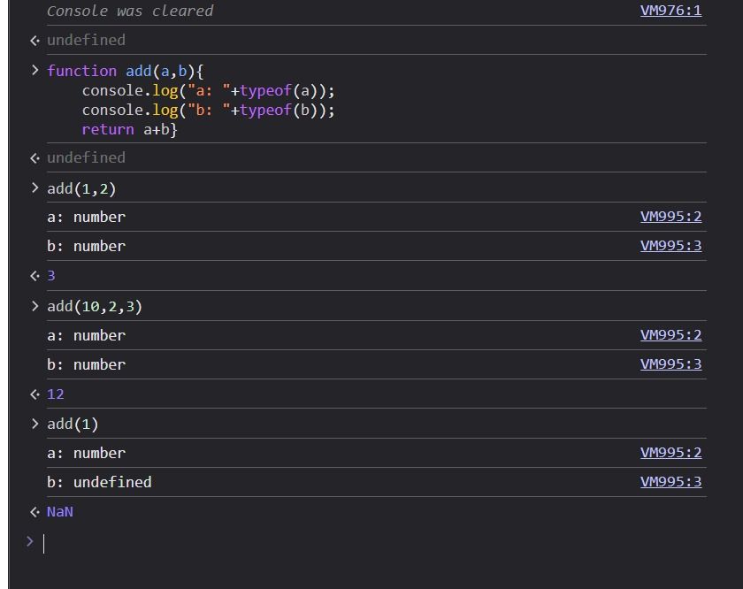

Example - To retrieve the values of radio buttons
<html>
<head>

<script>
function fun()
{
var markedCheckbox = document.getElementsByName("Qual");
for (var checkbox of markedCheckbox)
if (checkbox.checked)
window.alert(checkbox.value);
}
</script>
</head>
<body>
B.E. <input type="radio" value="BE" name="Qual">
M.E. <input type="radio" value="ME" name="Qual">
Ph.D <input type="radio" value="Ph.D" name="Qual">
<button id="btn" onclick="fun()">Click Me</button>

</body>
</html>

Example for onChange event
<head>
<script>
function fun1()
{
var s=document.getElementById("sel").value;
document.getElementById("p1").innerHTML="You have selected: "+s;
}
</script>

</head>
<body>
<select id="sel" onchange="fun1()">
<option>Audi</option>
<option>BMW</option>
<option>Scoda</option>
<option>Hyundai</option>
</select>
<p id="p1"> </p>
</body>

Example for onload event
<html>
<head>
<style>
div{
height:100px;
width:100px;
background-color: red;
}
</style>
<script>

function fun2()
{
document.getElementById("d1").style.backgroundColor="red"
}
</script>

</head>
<body onload="fun2()">
<div id="d1"></div><br>
</body>
</html>

Example – To retrieve the value from range
<html>
<head>
<script>
function fun()
{
window.alert(document.getElementById("r").value);
}
</script>
</head>

<body>
<input type="range" id="r" min="1" max="10" onchange="fun()">
</body>
</html>

Case statement
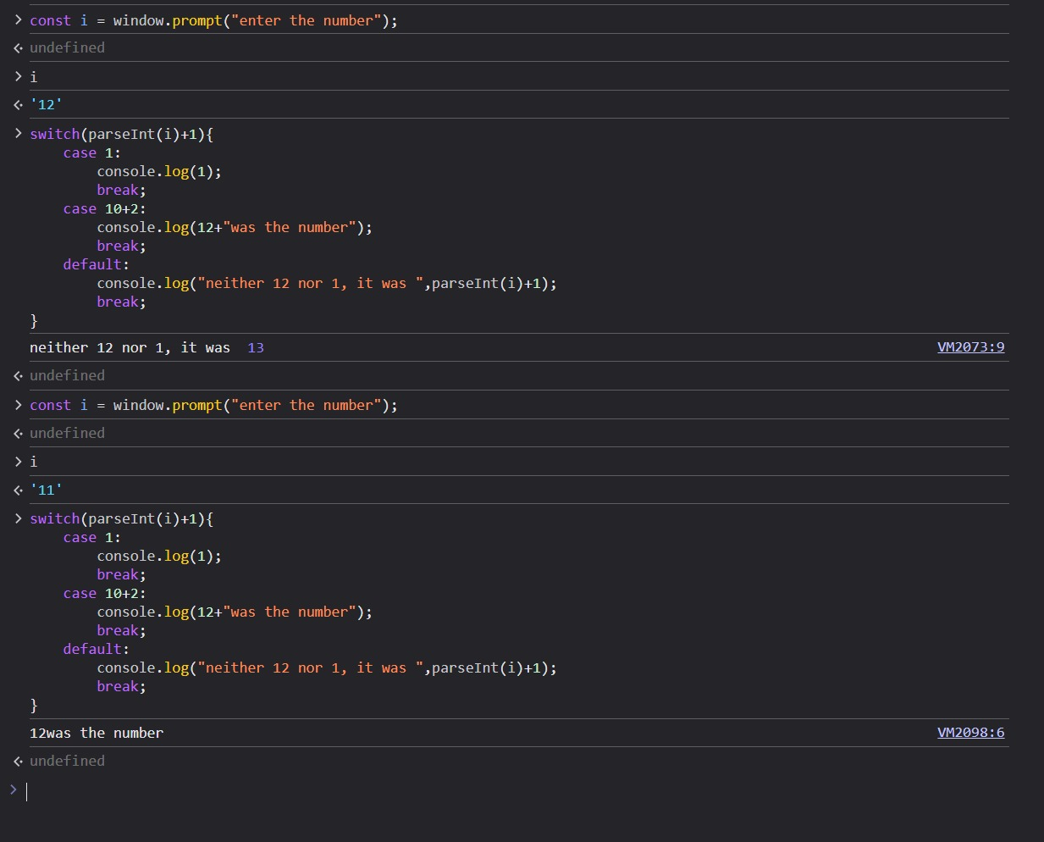

Example for Slice
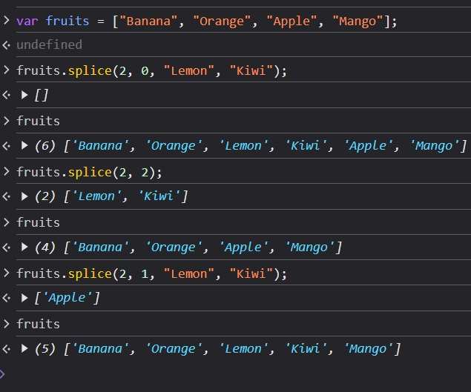
Digital Clock

<html>
<head>
<script>
function showTime()
{
var d=new Date();
var h=d.getHours();
var m=d.getMinutes();
var s=d.getSeconds();
document.getElementById('p1').innerHTML=h + ":" + m + ":" + s;
}
setInterval(showTime,1000);
</script>
</head>
<body onload="showTime()">
<p id="p1"></p>

</body>
</html>

